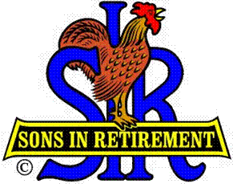**Las Trampas Branch 116**

**Luncheon Meeting Agenda**

**September 16, 2024, 11:30 AM**

**10:30** Social Hour

Greeters – Paul Ramacciotti, Joe Datzman

New Member Orientation – Dave Williams

Treasurer Table – Charlie Guthrie, Al Satake

Name Tags Table – Dennis Snarr

Raffle Table – Ben Bryce, Bob Huck

**11:25**  Five Minute Call

**11:30** Call to order – Big SIR

Pledge of Allegiance – Big SIR

Invocation/Remembrance – Terry Sherman

**11:35** Storyteller – Garrett Romain

**11:40** Member vote: 2025 Officers and Directors – Roger Craig

**11:43** Big SIR Report – Alan Pope

Introduce New Member – Erik Linak, Sponsor Jeff Johnson

Welcome Attendance of Speaker – Ed Holloway

Thanks to Nomination Committee – Roger Craig, Terry Grummitt, Ron Armijo, Jeff Johnson, Sam Beret

Free Lunch for Past Big SIRS

**11:46** Activity Reports - Mike Ward: Reports by certain Activity Chairmen

**12:00** Lunch

**12:25** Introduce Speaker – Little SIR

**12:27** Speaker – Ed Holloway, Blackhawk Museum Docent

**12:52**  Speaker Thank You – Big SIR

**12:54** Raffle Drawing – Bob Huck, Ben Bryce

Birthday Drawing – Little SIR

**13:00** Sing Happy Birthday – Paul King

Sing God Bless America – Paul King

**13:04** Adjourn; Next meeting, October 21, 2024